Step 1-2a Adjust MainDocument.as as shown below:

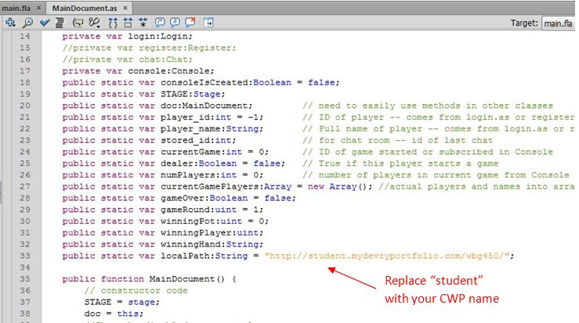

Replace “student” with your CWP name